Ex.No.5: MIMO System Simulation with BER Analysis

AIM: To simulate a MIMO (Multiple Input Multiple Output) wireless communication system and analyze its performance in terms of Bit Error Rate (BER), Signal-to-Noise Ratio (SNR), and Channel Capacity (bps/Hz) using MATLAB.
Objective:
- To evaluate the Bit Error Rate (BER) performance of a MIMO system under different SNR conditions.
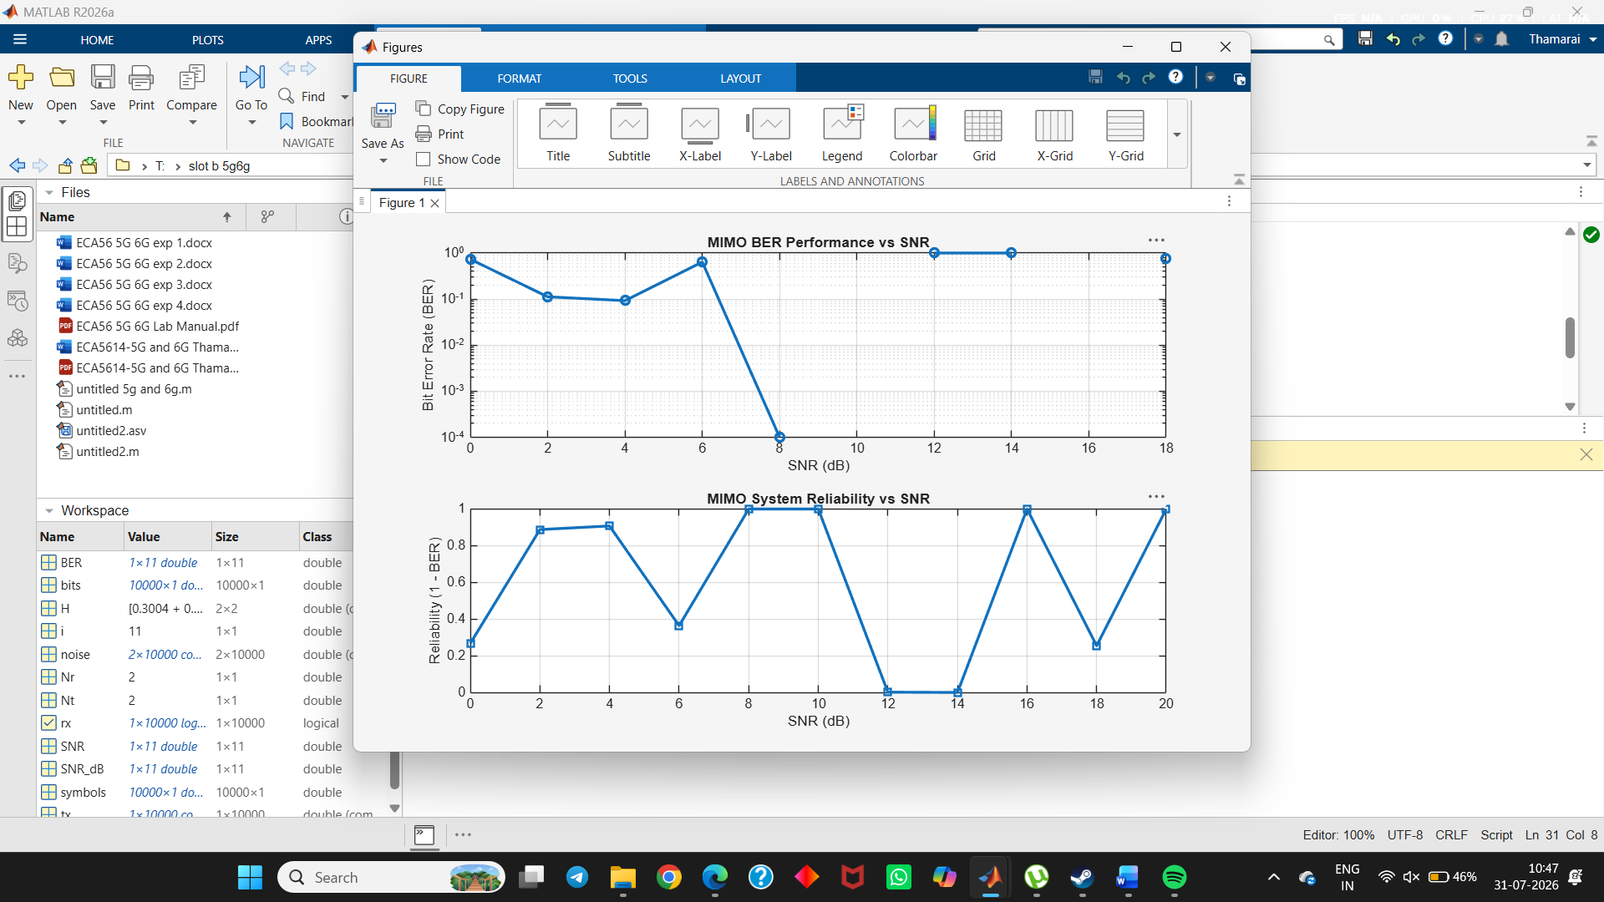
- To analyze the impact of Signal-to-Noise Ratio (SNR in dB) on the reliability and quality of MIMO communication.
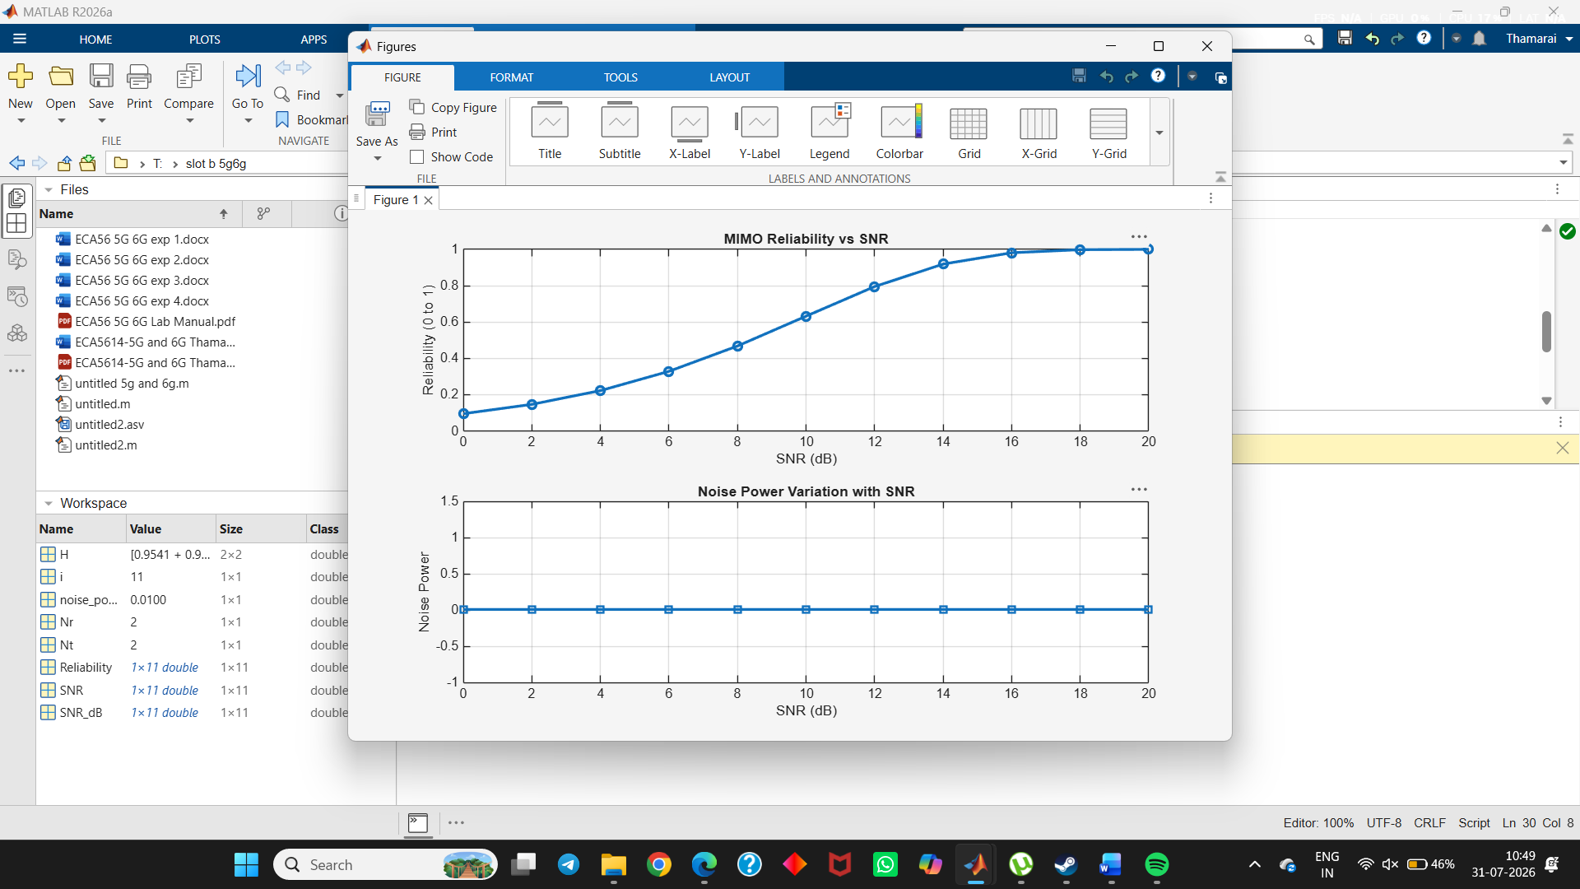
- To compute the Channel Capacity (bps/Hz) and study how MIMO improves spectral efficiency compared to single antenna systems.
